Suggestion of Polestar developer portal:

1. I noticed two ‘Save and continue’ button in car specification page. When clicked on them, the button take us to the next page which is review order page as seen below.

Specifying the first and second buttons. When clicking on the first button

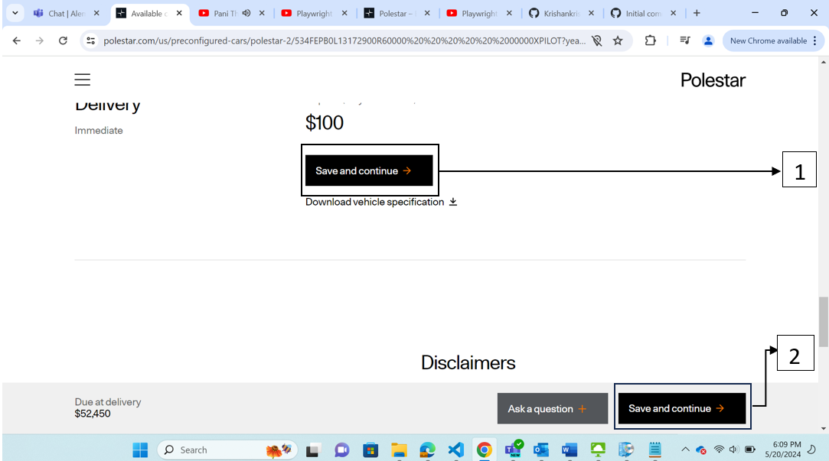

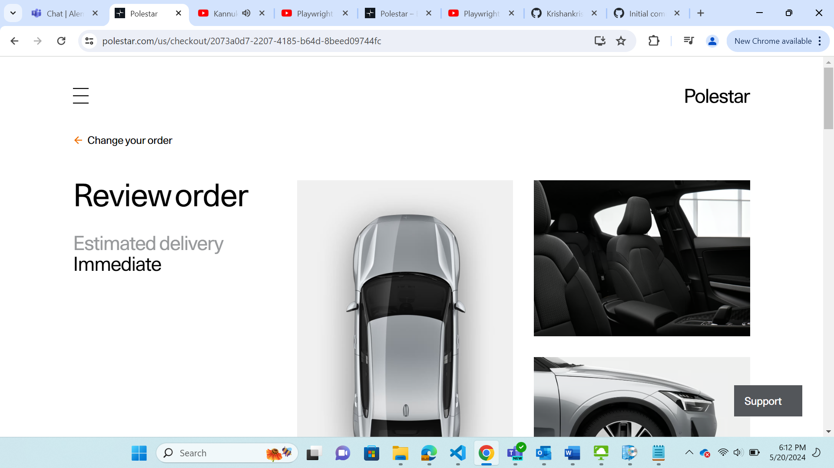

Clicking on the second Save and continue button.

Result: Both the button clicks navigated us to Review order page. Hence, as per my view we can have a single button.

1. Suggestion to have the customer details saved once a car has been selected for reservation. If a guest user has started to use the website and as soon as a car is been selected, if the session of the user gets expired, then the user has to search the same car in the new session throughout the list. By asking the customer to save the details  
   this can be avoided.

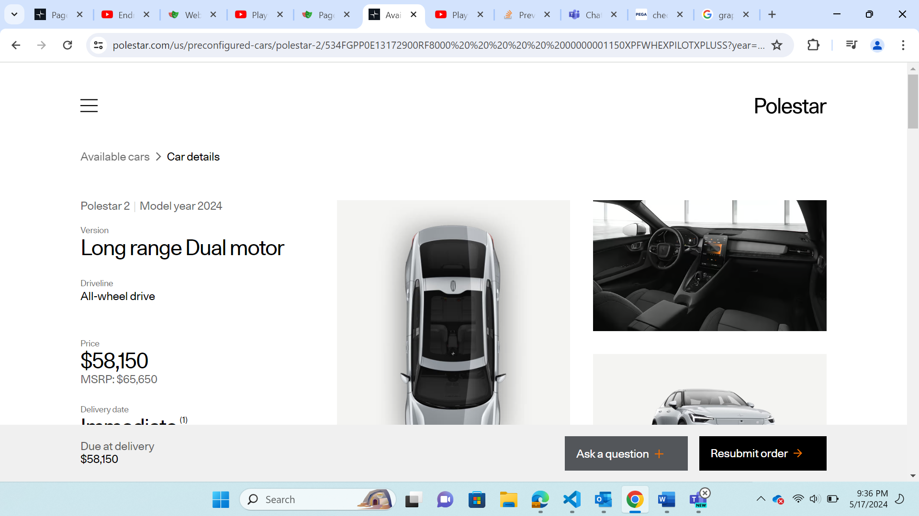

After clicking on Resubmit order, the review order page is navigated.

User can enter their details and click on save and continue button.

1. I noticed that if a customer after reserving a car, goes back and selects another car within 5 minutes, we have a decision dialog box to the user. In that dialog box, user will take a decision with which car he wants to continue. Here I am starting the screenshots with first time user has reserved a car.

User navigates back and chooses another car and is interested to view the details for that car.

With the same details customer click on Save and continue button.

The dialog box has appeared, but we have the same message twice.

Result: I suggest we can use the message once, as user should again read the same content.

1. I noticed that when we click on No in the above screenshot to continue with the previous active order. The page is landing on 404 error page.

1. Suggestion on website for making automation process little easier. I noticed that the mostly all the html tags are having their class id starting with ‘css-’. There is a risk that the second part of the class id be dynamic and might get changed from time to time. This will make the automation scripts to fail if tester has pointer to with class attribute. I have taken some efforts to not to point any element in case if it has a dynamic value.  
   Note: This might be a know one and could be accepted across. I am just specifying if this was not know.